 **GIK Institute of Engineering Sciences and Technology, Topi**  **Fall 2022 (FCSE) Midterm   
 02nd November 2022, 04:30 pm – 05:45 pm**

|  |  |  |
| --- | --- | --- |
| **Course Code: CE-221** | **Course Name: Logic Design** | |
| **Instructor Name : Engr. Ahsan Shah** | | |
| **Student Name:** | | **Registration No:** |

* Read each question completely before answering it. There are **2 Sections and 7 pages only.**
* In case of any ambiguity, you may make assumption. But your assumption should not contradict any statement in the question paper.
* Write the answer in the space below each question.

.

**Time**: 75 minutes. **Max Marks**: 45 points

Section 1 (Short Questions) [5 point each]

1. Given the 4-bit signed number X=X3 X2 X1 X0, write the simplest SOP expression for each of the following:

odd (should be 1 when X is odd and 0 otherwise): odd =___________________________

even (1 when X is even and 0 otherwise):           even =___________________________

positive (1 when X is positive and 0 otherwise):     positive =_________________________

negative (1 when X is negative and 0 otherwise): negative =_________________________

1. Explain at a high level in 1-2 English sentences how you would build a circuit that takes a two’s-complement 16-bit number and outputs 1 if and only if it is equal to 1. In this problem, you can use only AND, OR, and NOT gates. Your (AND, and OR) gates can take any number of inputs. You may include a picture if you find it helpful.

|  |
| --- |
|  |

1. Verify algebraically that the circuit shown below generates the “exclusive-NOR” function

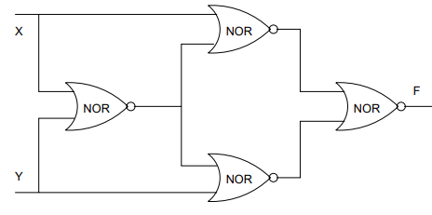

|  |
| --- |
|  |

1. Simplify the following Boolean expression by using Boolean algebra.

$$F=\overline{\left[\overline{\left\{A+ \overline{B}+\overline{C}\right\}}.\left\{A+\overline{B}\right\}+\overline{A}.C\right]}$$

|  |
| --- |
|  |

1. You are given the below circuit. The gate labeled “K gate” has the truth table given below. Your job is to analyze this circuit and come-up with the minimized two-level circuit for the same function that uses only AND, and OR gates (you may assume that complementary inputs, if needed, are directly available - e.g., both A and $\overline{A }$ are available). Hint: THINK.

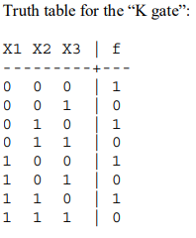

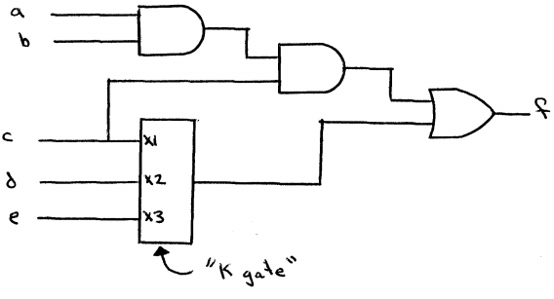

|  |
| --- |
|  |

Section 2 (Long Question) [10 point each]

1. Many offices and buildings use combination locks to control entry. As the design engineer of the Wonderful Door Security Company, you are asked to implement a door security system by using a card reader. There are four inputs to the card reader: inputs X, Y, and Z are used to validate the correct door code, and input V is used to check if the card reader is still valid. After the card reader is being read by the system, there are three outputs to this system: alarm (A), door open (D), and Error (E). Door (D) will only open when the decimal value of the binary inputs (X, Y, Z) is odd and the card reader is valid. The Error (E) signal goes on when the code on the card is correct (i.e. decimal value equal to odd) but the card is no longer valid. Finally, the alarm (A) will trigger when the code is incorrect. Design the circuit for the given scenario.

|  |
| --- |
|  |

1. In digital systems it is often necessary to have circuits that can shift the bits of a vector by one or more bit positions to the left or right. The circuit that can shift a four-bit vector W = w3w2w1w0 one bit position to the right when a control signal Shift is equal to 1 is given in **Figure 1**. If Shift = 1 then y3 = 0, y2 = w3, y1 = w2, y0 = w1, and k = w0. If Shift = 0 then Y = W and k = 0.

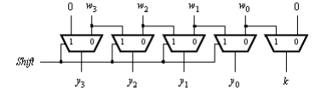

Figure 1: One bit shift

The shifter circuit in **Figure 1** shifts the bits of an input vector by one bit position to the right. It fills the vacated bit on the left side with 0. A more versatile shifter circuit may be able to shift by more bit positions at a time. If the bits that are shifted out are placed into the vacated positions on the left, then the circuit effectively rotates the bits of the input vector by a specified number of bit positions. Such a circuit is often called a barrel shifter. Design a four-bit barrel shifter that rotates the bits by 0, 1, 2, or 3 bit positions as determined by the valuation of two control signals S1 and S0. Hint: Truth table given

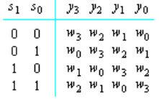

|  |
| --- |
|  |

**Boolean algebra Rules**

